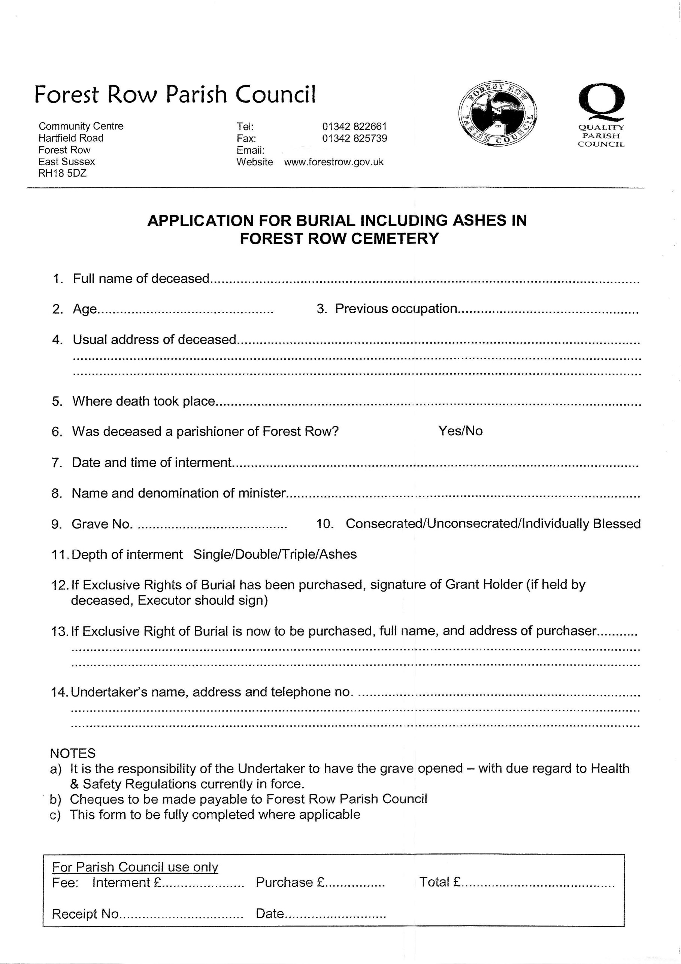

sue.young@forestrow.gov.uk

